INTEGRATED SUMMATIVE TASK 4

4.1

# Brief background about your business unit or organisation

BET Software is one of the most diverse betting software providers in Sub-Saharan Africa, providing reliable and user-friendly betting software on a global scale, while supporting incredibly large transactional volumes in a fast-paced industry.

# Goals and objectives

* Currently - key man reliance across all teams
* Disconnect between teams- dev teams and support
* Why is there reluctance with developers to be on standby?
* Retention of staff

Short term goals

* Creating a culture of sharing knowledge
* Upskilling team members - eliminate key man reliance
* Progression path - career goals - Help team members progress from graduate to developers, etc.

Long term goals

* No key man reliance
* Motivated team members
* Effective work saving time and quicker turnaround time

# Change management strategy

* Introduce a leadership programme - pairing with key team members in each space
* Implementation team- identify big brother pairing
* Help team members understand the need for a Knowledge management system - get their buy in by building our retention strategy.
* Encourage knowledge sharing behaviour.
* Supports performance appraisals and KPIs for the big brother as well
* Incentivise knowledge sharing

# A foundation

* **Created** - part of the academy process, create the documentation that you were taught- against the ticket (Ado) and training internally with team members and extended to dev support
* **Categorised** - documented per project/ product/ requirement on ADO
* **Shared** - education sessions, video recording, internally with team members

# Assess the current State

* **Culture** - creating a culture of learning, upskilling
* **People** - Nurturing growth
* **Processes** - the big brother Knowledge management academy
* **Technology** – ADO /Azure

# Establish Core Capabilities

* Ease of capturing knowledge - journal, tickets
* Syndication of knowledge for easy access - WIKI on ADO
* Available feedback mechanisms - final interview. During duration of programme, regular bi- monthly sessions tied in with the sprints to discuss progress and status.
* Performance measurements and reviews- tied in with feedback and performance appraisals, career roadmap (promotional framework). Burn down charts on ADO
* Added intelligence - Automatic flow of pull requests. As tickets get updated, emails are sent

# Knowledge management implementation team

* The key man reliance team member - could be from dev space, BA, QA, DBA and dev Support
* The graduate/ junior
* The team lead
* Tech lead
* Team coordinator to ensure updates going forward
* Based on projects or Knowledge Management Academy

Skills and representation covered by implementation team and big brother academy. Roles covered by the implementation team

# Knowledge management implementation road map

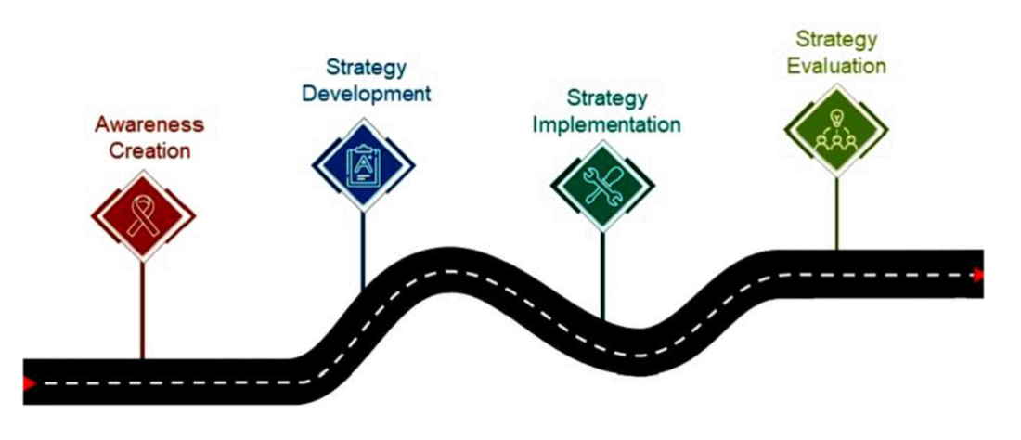

4.2

* Putting the above plan in action
* Continue to review, through awareness creation, development and implementation
* Learn lessons from the evaluation
* Assess the effectiveness of the academy
* Make improvements